Format:
- Teams will bowl two baker games and that combined game total score will determine their seed.
- Baker Games will be bowled with the following conditions:
  - Partner Athlete must bowl frames 1, 3, 5, 7, 9
  - Special Athlete must bowl frames 2, 4, 6, 8, 10
  - Each athlete will bowl all balls within their frame.
- The team will then bowl whichever team they are seed to bowl in a match.
- The winner will advance to the next round.
- Each round after the seed games will consist of one baker game.
- Rounds will continue until a champion, runner-up and semifinalist are established. If there are any ties in the seed game, the tiebreaker will be the highest individual game.
- If a tie remains, for the 2nd seed game, start at frame 10 and move back until the tie can be broken:
- For example, if you have a tie, see which unified pair had the higher score in frame 10 of game 2.
- If it is still tied, move to frame 9 and so on until you can break the tie.

School Name: ______________________________ Lane #: ______

Student-Athlete Names: _______________________________________________

Special Athlete
Partner Athlete
Special Athlete
Partner Athlete
Special Athlete
Partner Athlete
Special Athlete
Partner Athlete
Special Athlete
Partner Athlete

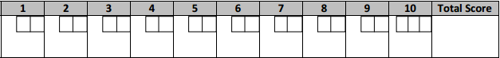

Special Athlete
Partner Athlete
Special Athlete
Partner Athlete
Special Athlete
Partner Athlete
Special Athlete
Partner Athlete
Special Athlete
Partner Athlete

Two Game Total: ___________ Seed #: ____________

