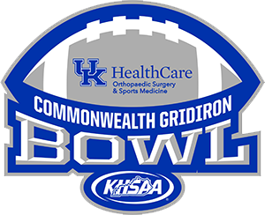 | UK Orthopaedics State Football Finals  Pass List Form  Bring this form to Kroger Field and upon arrival you will submit this form in exchange for comp tickets.  Each participating team is permitted 40 comp tickets per school and 25 cheerleaders (plus 2 coaches). Please list the name and cell phone number of each below. | KHSAA Form FB145  Rev. 01/06

TEAM |  |  |  | PERSON SUBMITTING FORM

Below, list the 40 names and cell phone numbers of those receiving comp tickets.

 | NAME | Cell Phone Number  Player, Coach, Etc.)
1
2
3
4
5
6
7
8
9
10
11
12
13
14
15
16
17
18
19
20
21
22
23
24
25
26
27
28
29
30
31
32
33
34
35
36
37
38
39
40

Below, list the 27 names and cell phone numbers of cheerleaders and cheer coaches attending the game.

 | CHEERLEADER NAME | Cell Phone Number  Player, Coach, Etc.)
1
2
3
4
5
6
7
8
9
10
11
12
13
14
15
16
17
18
19
20
21
22
23
24
25

 | CHEER COACH NAME | Cell Phone Number  Player, Coach, Etc.)
1
2

